**Cap Ex** **OpEx**

Making upfront investment for future use/profit pay for what you actually use

**Types of Cloud Services**

**IaaS** **PaaS** **SaaS**

Virtual Machine WebApps Office365, Salesforce

**Additional Service Types**

FaaS – Functions as a Service

DBaaS – Database as a Service

DaaS – Desktop as a Service

IoTaaS – IoT as a Service

AIaaS – AI as a Service

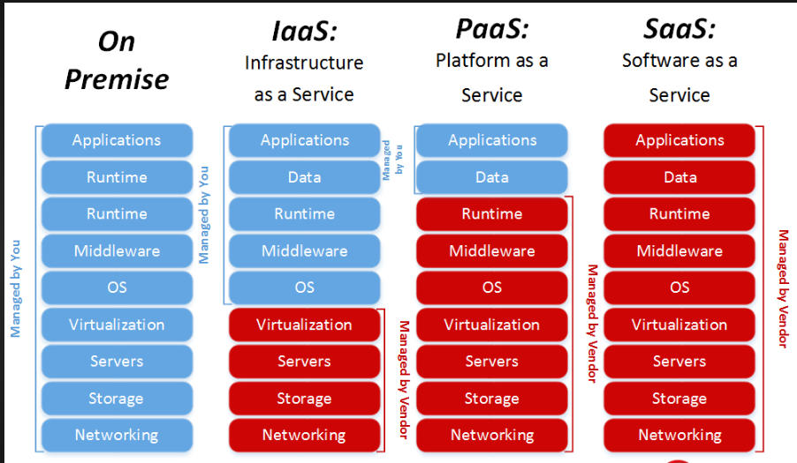

**Types of Cloud**

**Public** **Private** **Hybrid**

AWS VMware Cloud Azure Arc

Azure Redhat Openshift container platform AWS Outposts

GCP Azure stack

IBM Cloud

Oracle Cloud

**Cloud Providers growth**

Cloud %Growth

AWS 12%

Azure 29%

Google 24%